Annual Internal Audit Report 2021/22

Goring Heath Parish Council

www.goringheath.com
During the financial year ended 31 March 2022, this authority's internal auditor acting independently and on the basis of an assessment of risk, carried out a selective assessment of compliance with the relevant procedures and controls in operation and obtained appropriate evidence from the authority.
The internal audit for 2021/22 has been carried out in accordance with this authority's needs and planned coverage. On the basis of the findings in the areas examined, the internal audit conclusions are summarised in this table. Set out below are the objectives of internal control and alongside are the internal audit conclusions on whether, in all significant respects, the control objectives were being achieved throughout the financial year to a standard adequate to meet the needs of this authority.
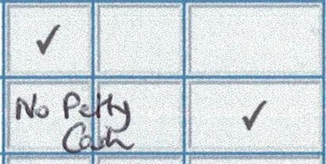
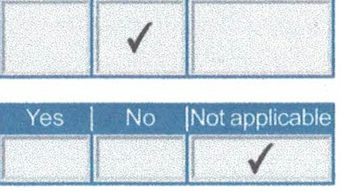
Internal control objective
I I INot
Yes fNiol· l covered'
*

- Appropriate accounting records have been properly kept throughout the financial year.
- " This authority complied with its financial regulations, payments were supported by invoices, all expenditure was approved and VAT was appropriately accounted for.
■·-

- This authority assessed the significant risks to achieving its objectives and reviewed the adequacy of arrangements to manage these.
!✓II

- The precept or rates requirement resulted from an adequate budgetary process; progress against the budget was regularty monitored; and reserves were appropriate.
- Expected income was fully received, based on correct prices, property recorded and promptly banked; and VAT was appropriately accounted for.
- Petty cash payments were property supported by receipts, all petty cash expenditure was approved and VAT appropriately accounted for.
- Salaries to employees and allowances to members were paid in accordance with this authority's approvals, and PAYE and NI requirements were property applied.
!✓II

✓

- Asset and investments registers were complete and accurate and property maintained. f"T r-
- Periodic bank account reconciliations were property carried out during the year. F✓
- Accounting statements prepared during the year were prepared on the correct accounting basis (receipts
and payments or income and expenditure), agreed to the cash book, supported by an adequate audit ✓
trail from undertying records and where appropriate debtors and creditors were property recorded.
- If the authority certified itself as exempt from a limited assurance review in �020/21, it met the
exemption criteria and correctly declared itself exempt. (If the authority had a limited assurance ✓

review of its 2020121 AGAR tick "not covered'?
111,
- The authority publishes information on a free to access website/webpage up to date at the time of ✓-
I I .,
the internal audit in accordance with any relevant transparency code requirements j.

- The authority, during the previous year (2020-21) correctly provided for the period for the exercise of public rights as required by the Accounts and Audit Regulations (evidenced by the notice published ✓ on the website and/or authority approved minutes confirming the dates set).
- The authority has complied with the publication requirements for 2020/21 AGAR

(see AGAR Page 1 Guidance Notes).

0. (For local councils only)
Trust funds (including charitable)- The council met its responsibilities as a trustee.
For any other risk areas identified by this authority adequate controls existed (list any other risk areas on separate sheets if needed).

Date(s) internal audit undertaken

04/05/2022
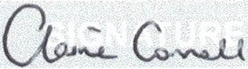
Signature of person who
Name of person who carried out the internal audit

Claire Connell
06/05/2022

carried out the internal audit Date

*If the response is 'no' please state the implications and action being taken to address any weakness in control identified (add separate sheets if needed).
**Note: If the response is 'not covered' please state when the most recent internal audit work was done in this area and when it is next planned; or, if coverage is not required, the annual internal audit report must explain why not (add separate sheets if needed).

